Green Jobs in Tourism Vocational School

¹Yani Achdiani, ²Isma Widiaty*, ³Mirna Purnama Ningsih, ⁴Sugeng Rifqi Mubaroq, ⁵Muh Abdul Latif, ⁶Silmi Farhah Fauziah
Universitas Pendidikan Indonesia, Indonesia
Email : ²isma@upi.edu*, ⁶silmifarhahf@upi.edu
* Correspondence author

ARTICLE INFO |  | ABSTRACT
Article history  Received Jul 16, 2024  Revised Sep 11, 2024  Accepted Sep 24, 2024 |  | This study employs a comprehensive bibliometric analysis to examine the evolving landscape of Green Jobs in tourism vocational education. Utilizing data from the Scopus database, the research analyzes 93 relevant documents using VOSviewer and Biblioshiny (R) for visualization and analysis. The study reveals significant trends in research output, geographic distribution, and thematic focus areas. Key findings include a marked increase in research activity from 2013 to 2020, with a peak in 2020, followed by a decline potentially influenced by the COVID-19 pandemic. Prominent research clusters center around sustainable development, ecotourism, vocational education, and emerging technologies in tourism. European countries, particularly Italy, emerge as leading contributors, with growing participation from Asia-Pacific and emerging economies. The study highlights the integration of sustainability principles, digital skills, and green human resource management in tourism education curricula. However, it also uncovers research gaps, including limited focus on specific green technologies, climate change adaptation strategies, and crisis management skills. Methodological limitations, such as a scarcity of longitudinal and mixed-methods studies, are noted. The paper proposes future research directions, emphasizing cross-cultural comparative studies and interdisciplinary approaches. It underscores vocational education's role in preparing a sustainability-focused, resilient workforce for the evolving tourism industry. This analysis provides insights for curriculum designers, policymakers, and researchers in aligning educational strategies with the needs of Green Jobs in tourism.  This is an open access article under the CC–BY-SA license.
Keywords
Green Jobs
Tourism Vocational School
Sustainable Tourism
Vocational Education
Bibliometric Analysis

Introduction
Climate change and environmental degradation have emerged as pressing global concerns, leading various sectors, including tourism, to adjust and contribute to sustainable development (Grizane, 2023; Stojanovska-Stefanova et al., 2019). The 2030 Agenda for Sustainable Development was adopted by the United Nations in 2015, which delineates 17 Sustainable Development Goals (SDGs) that are directly related to sustainable tourism and the creation of quality employment opportunities. SDG 8 (Decent Work and Economic Growth) and SDG 12 (Responsible Consumption and Production) are particularly important for the tourism sector. SDG 8.9 specifically outlines the objective of “formulating and implementing policies to foster sustainable tourism that generates employment and supports local culture and goods” by the year 2030 (Alvarez-Risco et al., 2020; Stanef-Puică et al., 2022; Yilmaz, 2021). Consequently, the notion of “Green Jobs” has surfaced as a means to address the demand for a workforce capable of bolstering the green economy and attaining SDG targets.
Within the tourism sector, Green Jobs hold significant importance due to the industry's capacity for job generation and its notable environmental footprint. Sustainable tourism serves to support environmental and cultural preservation, while also contributing to the achievement of diverse SDG goals, including SDG 11 (Sustainable Cities and Communities), SDG 13 (Climate Action), and SDG 14 (Life Below Water) (Ariyanto, 2022; Stoican et al., 2022).
Vocational High Schools, institutions devoted to preparing skilled laborers, play a crucial role in readying younger generations to occupy Green Jobs in the tourism field. This aligns with SDG 4 (Quality Education), particularly target 4.4, which strives to substantially enhance the number of youths and adults possessing relevant skills for decent work by 2030. Nevertheless, the extent to which scholarly research and literature have tackled the integration of Green Jobs concepts and SDG principles in tourism vocational education at the vocational school level remains uncertain (Sumbodo et al., 2019; Ulfah et al., 2020; Yusti, 2019).
The assimilation of Green Jobs concepts into tourism vocational education at the vocational school level signifies a pivotal yet insufficiently studied domain, especially concerning the realization of Sustainable Development Goals (SDGs) (Agustin et al., 2018; Haloho et al., 2023; Kamis et al., 2017; Legrand et al., 2011; Stanef-Puică et al., 2022). This study seeks to bridge this knowledge gap by conducting an exhaustive bibliometric analysis of the prevailing literature. The primary inquiry guiding this research is: "How has the scholarly discourse on Green Jobs in tourism vocational education progressed, and what are its implications for curriculum design?" To address this overarching query, we will scrutinize the evolution and patterns of pertinent research, pinpoint key contributors and institutions, delineate primary themes and concepts, and evaluate the repercussions of our discoveries.
The aims of this research encompass delivering a methodical overview of the research terrain, spotlighting influential publications and scholars, and unveiling emerging trends and voids in the literature. By doing so, we strive to provide valuable insights for curriculum designers, policymakers, researchers, and industry professionals. This study is especially timely and imperative given the escalating significance of sustainable tourism and the necessity for a proficient workforce adept at bolstering a green economy.
By addressing these research questions and objectives, this study aims to contribute significantly to the body of knowledge on Green Jobs in tourism vocational education, ultimately supporting the development of a more sustainable and resilient tourism industry in Indonesia and beyond.
Literature Review
Green jobs (GJs) in vocational education at tourism Vocational High Schools play a crucial role in the intersection of sustainable development and workforce training (Sulich & Zema, 2018). These jobs represent the integration of sustainability into various sectors, with a focus on roles like green self-employment and green entrepreneurship (Diep & Hartmann, 2016). The concept of GJs is essential for the green economy, supporting sustainable labor market transitions.
Recent research has expanded our understanding of the importance of education for sustainable development (ESD) in tourism. ESD in tourism should not only focus on environmental aspects but also incorporate economic and social dimensions, particularly at the university level (Zagonari, 2009). This multidimensional approach is crucial for preparing future professionals to address complex sustainability challenges in the tourism industry.
In the hospitality and tourism industry, green human resource management (GHRM) and employee green creativity (EGC) have gained prominence, particularly during and in the aftermath of the COVID-19 pandemic (Elkhwesky et al., 2022; Mínguez et al., 2021). This indicates a growing recognition of the importance of sustainable practices within the sector. (Niñerola et al., 2019) conducted a bibliometric analysis on sustainability in tourism and hospitality education, revealing an increasing trend in research on this topic and highlighting the need for more practical and experiential learning approaches.
The integration of technology in sustainable tourism education has also become a focal point of recent research. (Gössling, 2021) explores the concept of 'smart tourism' and its implications for sustainability, emphasizing the need for tourism education to incorporate digital skills and data analytics. This aligns with the findings of (Manmohan et al., 2023), who demonstrate a notable increase in research output related to green technology and environmental sustainability in tourism, particularly from China, in 2020.
The relationship between tourism and education has been extensively studied, showing that tourism can enhance environmental, cultural, and social awareness, contributing to a more sustainable industry (Coll-Ramis et al., 2023; Guillén-Peñafiel et al., 2022). (Seraphin et al., 2021) further emphasize the role of tourism education in achieving Sustainable Development Goal 4 (Quality Education), highlighting the need for curricula that integrate sustainability principles across various disciplines.
However, challenges persist in implementing sustainable practices in tourism education. (Higgins-Desbiolles, 2018) critically examines the concept of sustainable tourism, arguing for a more transformative approach in education that challenges existing paradigms and promotes social justice. This perspective is particularly relevant in the context of vocational education, where practical skills must be balanced with critical thinking and ethical considerations.
Recent global events, particularly the COVID-19 pandemic, have underscored the need for resilience and adaptability in the tourism sector. (Sigala, 2020) explores the impact of COVID-19 on tourism education, emphasizing the need for curricula that prepare students for crisis management and sustainable recovery strategies. This aligns with the findings of (Coghlan, 2019), who highlights the challenges of implementing sustainability practices in tourism and the importance of equipping students with skills to navigate complex, real-world scenarios.
Research also emphasizes the importance of renewable energy sources and energy efficiency in tourism for long-term sustainability (Gupta & Hasnain, 2022). (Zhang et al., 2022) provide evidence from China's green patents, demonstrating how environmental regulations can promote green technological innovation in urban areas, including the tourism sector. This highlights the need for vocational education to stay abreast of technological advancements and policy changes that affect sustainable tourism practices.
In conclusion, recent literature underscores the multifaceted nature of green jobs in tourism vocational education. It emphasizes the need for curricula that integrate sustainability principles, digital skills, crisis management, and adaptability. The evolving research landscape also points to the importance of cross-cultural perspectives and the need for education that prepares students to navigate the complex, global challenges of sustainable tourism development. As the field continues to evolve, vocational education plays a critical role in preparing future tourism professionals for green jobs, supporting the industry's transition towards sustainability in line with new consumer demands and global sustainability goals.

Method
This study employed a bibliometric analysis approach to examine the literature on Green Jobs in tourism vocational education. The research process consisted of data collection, data processing, and data analysis phases.
Data Collection
The data for this study were primarily sourced from the Scopus database, which is widely recognized for its comprehensive coverage of peer-reviewed literature in various fields, including tourism and vocational education. The search was conducted using a combination of relevant keywords, including but not limited to "Green Jobs," "Green Skills," "Sustainable Tourism," "Vocational Education," and "Vocational School". The exact search string used was:
( TITLE-ABS-KEY ( "Green job" OR "Green Skill" OR "Sustainabl*" ) AND TITLE-ABS-KEY ( "Tourism*" OR "Travel" OR "Hospitality" OR "Tourist*" OR "Eco-tourism" OR "Cultural Tourism" OR "Heritage Tourism" OR "Destination Management" OR "Tourist Behavior" OR "Travel Industry" OR "Tourism Economics" ) AND TITLE-ABS-KEY ( vocatio* ) )
The search was limited to articles published up to June 2024. This initial search yielded 93 documents.
While Scopus provides a robust dataset, we acknowledge the potential limitations of using a single database. To address this, we conducted a complementary search using Google Scholar to identify any highly cited grey literature or reports from major international organizations relevant to our topic. This additional step helped to ensure that key non-academic publications were not overlooked, although they were not included in the main bibliometric analysis.
Furthermore, to enhance the contextual understanding of our findings, we reviewed reference lists of the most cited papers identified in our Scopus search. This snowballing technique allowed us to identify any seminal works or important studies that might not have been captured in our initial database search.
The final dataset for the bibliometric analysis consisted of the 93 documents from Scopus, ensuring a focused and manageable corpus for in-depth analysis. The supplementary materials identified through Google Scholar and reference list checking were used to inform our discussion and interpretation of results, providing a more comprehensive view of the field.

Data Processing
The search results were exported from Scopus in both CSV and RIS formats to ensure compatibility with the analysis tools. The exported data included information such as authors, titles, abstracts, keywords, publication years, source titles, citations, and bibliographic information.
Data Analysis
Bibliometric analyses were conducted using two complementary software tools, VOSviewer (version 1.6.17) and Biblioshiny (R package, version 4.2.2). Biblioshiny, an R-based tool for bibliometric analysis, was used to perform more detailed statistical analyses. These two tools were used for the following analyses:
- Co-authorship analysis: To identify collaboration patterns among authors and institutions.
- Co-occurrence analysis: To map the relationships between keywords and identify main research themes.
- Citation analysis: To visualize the citation patterns and identify influential works.
- Descriptive analysis: Annual scientific production, top authors, top journals, and most cited papers.
- Content analysis: Word frequency and trend topics over time.
- Conceptual structure mapping: Using techniques such as co-word analysis and thematic mapping.
- Intellectual structure analysis: Including co-citation networks and historiograph analysis.
The combination of these tools allowed for a comprehensive analysis of the literature, providing both visual and statistical insights into the research landscape of Green Jobs in tourism vocational education.
Data Interpretation
The results from VOSviewer and Biblioshiny were carefully examined and interpreted in the context of the research questions. Patterns, trends, and significant findings were identified and synthesized to address the research objectives.
The participants consist of teachers and vocational high school students. By utilizing population data of teachers and SMK Negeri (State Vocational High School) spread around West Java Province. The criteria of SMK (Vocational High School) which has superiority in every regency, that is Bandung City, Bandung Regency, West Bandung Regency, Tasikmalaya City, Ciamis Regency, and Sukabumi Regency. The chosen vocational schools in this research are the schools that have superiority in the service area. The criteria used to identify the superiority is seen from accreditation, internet speed, and certification of ISO 9001:2008.
The main data of education from the Ministry of Education, Research, Technology, and Culture of the Republic of Indonesia shows that West Java Province has 288 (10%) of state schools and 2634 (90%) of private schools, this research uses the population of state schools in West Java. The data population consists of teachers and final year students with the details of the number of teachers’ population is 1.644 and 7.784 of final year students. In order to obtain participants, this research exerts Slovin method with stratified sample analysis. From the analysis, it is obtained that the result per school needs minimally 5 teachers and 31 students. The participants from six vocational high schools in West Java consist of 261 participants, that is 43 of teachers and 218 of students. The data of participant percentage seen from gender consists of 55,17% female and 44,83% male, and it is also gained from the data percentage of students’ aspirations who are the participants that after graduating from the school, 52,72% of them want to work, 19,67% want to continue their study, and 27,62% want to be entrepreneurs.
Instruments and Data analysis
The instruments used in this research are questionnaire, with the scale of measurement which is used is five likert scale consists of level 1 to 5, that is: (1) totally inappropriate, (2) inappropriate, (3) sufficiently appropriate, (4) appropriate, and (5) very appropriate. The research instruments consist of seven aspects of the vocational high school activities process, such as: school subjects, extracurricular, self-development/career-guidance, the switch of concept from theory to practice, learning materials, school culture, local content subject (Mulyani, 2010).
This research uses quantitative descriptive method, descriptive quantitative analysis technique which is used for testing, and a measurement based on calculation of mathematics and statistics. The data collecting method uses survey, observation, and questionnaire. The research by using quantitative methods utilizes theory deductively with the aim to test or verify a theory rather than develop it. Hence, a quantitative research should propose a theory, collect the data to examine the theory and declare a confirmation or disconfirmation for the theory in accordance with the obtained result (Creswell, 2016).
The stages of processing and analyzing data instrument tests are; first, instrument validity test to find out whether the questions of instruments are already matched with the built theory concept. In general, an item is declared valid if it has an rxy value above 0.3, although there are also experts who say that an item validity value of 0.25 is said to be valid (Idrus 2009). The validation test criteria are if the price of t count > t table with a confidence level of 95% and degrees of freedom (n-2) then the question item is said to be valid. We conducted the validity test using Office Excel software and the SPSS program.24.
The result of instrument validity is that from all indicators, there is only one invalid instrument in the four variable items of entrepreneurship ecosystem aspect of actors (business communities surrounding the schools contribute in the development of educational entrepreneurship). Second, the result of the reliability test on each construct has Cronbach’s alpha value with > 0,06 on each. The result indicates that the collected data by using questionnaire instruments either variable X1 (entrepreneurship ecosystem), X2 (digital technology ecosystem), or variable Y (vocational high school) are reliable.
Third, this research uses the frequency distribution analysis RLA (Respondents’ Level of Achievement) technique to analyze the collected data. Respondents’ Level of Achievement is an evaluation method by arranging evaluated persons based on their level towards the varieties of evaluated characteristics. The research method shows a scale assessment, “Master Scale”, it is a measurement scale that generally displays five levels of certain characteristics; very good, good, sufficient, insufficient, and not good (Sugiyono, 2012).
Frequency distribution is a statistical method used to present data in the form of tables or graphs, with the aim of showing the distribution or spread of values in a group of data. Frequency distribution is used to find out how respondents' achievements are spread across various categories or certain intervals. This is important to know the patterns, tendencies, and characteristics of respondent data. Several stages determine the analysis of frequency distribution, such as; determining the range of data, calculating the minimum and maximum values of respondent achievement data, determining the number of classes or categories in the frequency distribution can be determined by the Sturges rule, determining categories or intervals, calculating relative frequencies, calculating cumulative frequencies, calculating averages, calculating standard deviations, and data interpretation and data visualization. The research result covers respondents’ general description, validity test, reliability test, and frequency distribution analysis by using SPSS 24 which is then reprocessed to acquire the Respondents’ Level of Achievement value percentage.

Result and Discussion
Overview of Research Development and Trends
Annual Scientific Production
The analysis of annual scientific production in the field of Green Jobs in tourism vocational education reveals a dynamic and evolving research landscape (Figure 1). The overall trend demonstrates a clear progression from a nascent field with sporadic publications to a more established area of study, culminating in a significant peak of research output.
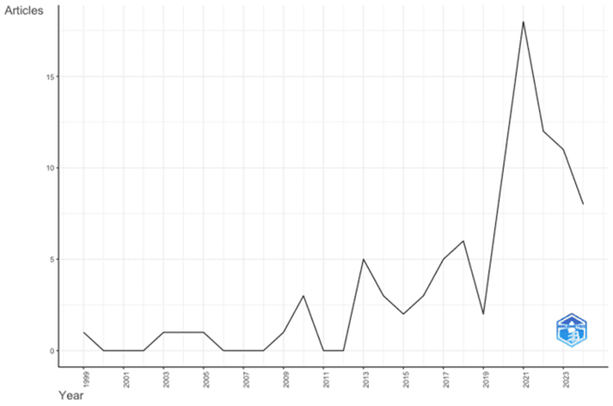
Fig 1: The number of publications per year
The analysis of annual scientific production in the field of Green Jobs in tourism vocational education reveals a dynamic and evolving research landscape (Figure 1). The overall trend demonstrates a clear progression from a nascent field with sporadic publications to a more established area of study, culminating in a significant peak of research output.
The inclusion of grey literature sources, such as reports from government agencies, NGOs, and international organizations, provided valuable insights that complemented the academic literature. These sources offered practical perspectives on the implementation of green jobs initiatives in tourism, highlighting:
• Current industry trends not yet reflected in academic research
• Policy recommendations and best practices from various global regions
• Challenges and opportunities identified by practitioners in the field
• Case studies of successful green jobs programs in tourism vocational education
The integration of these sources enhanced our understanding of the practical applications of theoretical concepts and helped bridge the gap between academic research and industry practice.
In the early years, from 1999 to 2007, the field was characterized by minimal and inconsistent research activity. This period saw several years with no publications, interspersed with occasional single publications, suggesting that the topic was still emerging and had not yet gained widespread academic attention. A shift began to occur around 2008, marking the start of an emergence period that lasted until 2012. During this time, there was a noticeable increase in research activity, albeit still at relatively low levels. This phase was marked by fluctuations in output, including a small peak in 2009, indicating growing interest but lack of sustained momentum. The years 2013 to 2017 represented a growth phase for the field. This period showed a more consistent upward trend in publications, with a notable peak in 2013. Despite a slight dip in 2015, the overall trajectory remained positive, suggesting that the topic was gaining traction within the academic community and attracting more researchers.
The most dramatic growth occurred between 2018 and 2020, marking a period of rapid acceleration in research output. This sharp increase culminated in a peak of approximately 18-20 publications in 2020, representing the zenith of research activity in the field. This surge might be attributed to factors such as increased global focus on sustainability, growing interest in green jobs, or policy initiatives promoting sustainable tourism. The observed decline in research output after 2020 warrants further investigation. While it could be attributed to various factors, the global COVID-19 pandemic likely played a significant role. The pandemic severely impacted the tourism industry and may have shifted research priorities. Future studies could explore how this event has influenced the focus of green jobs research in tourism and whether it has led to new areas of inquiry, such as crisis management and resilience in sustainable tourism.
Interestingly, the years following this peak (2021-2023) show a notable decline in publications. By 2023, the number of publications had decreased to about 8, marking a significant drop from the 2020 peak. This recent decline could be interpreted in several ways – it might represent a natural consolidation phase after rapid growth, a shift in research priorities, or the impact of external factors such as the global pandemic on research activities.
Overall, this trend analysis paints a picture of a field that has evolved from a niche area of study to a more established research domain. The pattern of growth, particularly the rapid acceleration in recent years, suggests that the topic of Green Jobs in tourism vocational education has gained significant relevance in the academic community. However, the recent decline also indicates that the field may be entering a new phase, possibly of consolidation or transformation. This trajectory underscores the dynamic nature of the field and points to potential opportunities for further development and exploration in the coming years.
Geographic Distribution of Research
An analysis of research contributions per country in the area of Green Jobs in tourism vocational education can be seen in figure 2, revealing significant regional trends and gaps, providing insight into the global landscape of this emerging field.
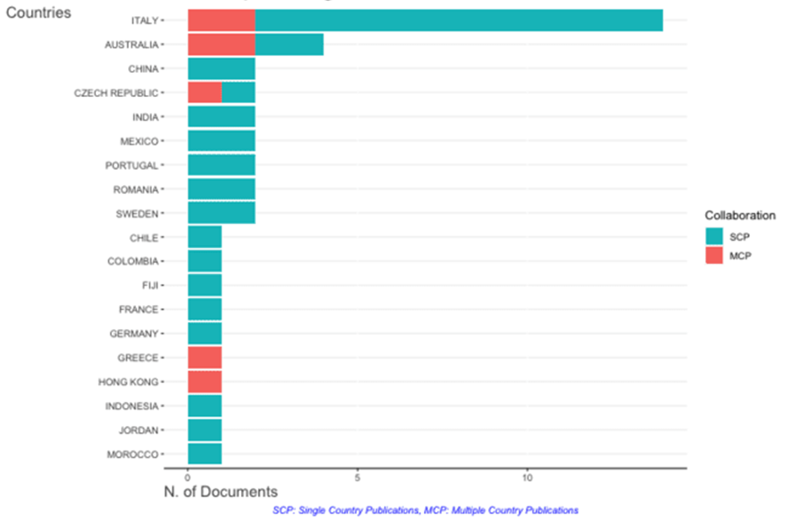
Fig 2: The top countries contributing to the research
European countries, led by Italy, demonstrate a clear dominance in this research area. Italy's substantial contribution, encompassing both single country publications (SCP) and multiple country publications (MCP), positions it as the leading force in the field. The strong presence of other European nations such as the Czech Republic, Portugal, Romania, Sweden, France, Germany, and Greece further underscores the continent's commitment to this area of study. This European focus may reflect the region's advanced tourism industry and its proactive stance on sustainable development and vocational education (Acampora et al., 2018; Angiola et al., 2015; Chen et al., 2020).
The Asia-Pacific region also shows significant engagement, with Australia emerging as the second-highest contributor. Australia's balanced output of both SCP and MCP indicates not only a strong domestic research agenda but also active participation in international collaborations (Christoff, 2008; Foo & Lam, 2013). China and India's notable contributions, primarily through SCP, suggest a growing interest in sustainable tourism and green jobs within these large, rapidly developing economies (Pu & Shuai, 2013). The presence of Fiji on the list is particularly interesting, potentially indicating a specific focus on sustainable tourism and green jobs in island economies that are often heavily reliant on the tourism sector (Natuva, 2021).
The Americas are represented in this research landscape, albeit to a lesser extent, with contributions from Mexico, Chile, and Colombia. While their research output is smaller compared to the European and Asia-Pacific leaders, their inclusion demonstrates the global relevance of the topic and suggests potential for growth in these regions (Osorio & Nieves, 2019).
An encouraging trend is the participation of emerging economies such as China, India, Mexico, and Indonesia. Their involvement in this research area likely reflects the growing importance of their tourism sectors and an increasing focus on sustainable practices and vocational education to support economic development (Asnawi & Djatmiko, 2015).
However, the data also highlights significant regional disparities. The notable absence of African countries (with the exception of Morocco) and limited representation from the Middle East (only Jordan is listed) points to a potential gap in research focus or capacity in these regions. This disparity may indicate opportunities for increased international collaboration and research capacity building initiatives (Fadeeva & Mochizuki, 2007; Fang et al., 2022).
The diverse economic backgrounds of the contributing countries, ranging from highly developed economies like Sweden and Germany to developing nations like Indonesia and Colombia, underscore the universal relevance of Green Jobs in tourism vocational education (Osorio & Nieves, 2019; Pavlova, 2018). This diversity suggests that the topic resonates across different stages of economic development, likely due to the global nature of both tourism and sustainability concerns.
Based on the findings, it can be concluded that while research in this area shows a clear trend towards European and Asia-Pacific contributions, the global distribution of participating countries shows a wide range of interest and relevance. The underrepresentation of African and Middle Eastern countries in this research landscape highlights a significant gap. Future research efforts should aim to include perspectives from these regions, as they may offer unique insights into sustainable tourism practices and green job development in diverse economic and cultural contexts.
Subject Area Distribution
The bibliometric analysis revealed a very diverse disciplinary landscape, with contributions from 16 different academic fields, as shown in figure 3. Social Sciences emerged as the most dominant discipline, contributing 46 publications (23.7% of the total). Business, Management and Accounting followed with 31 publications (16.0%), while Environmental Sciences accounted for 24 publications (12.4%). Earth and Planetary Sciences and Computer Science also made considerable contributions, with 17 (8.8%) and 13 (6.7%) publications respectively. Other disciplines, including Engineering, Economics, Physics and Astronomy, and others, contributed less than 10 publications each but collectively represent a broad spectrum of academic perspectives.
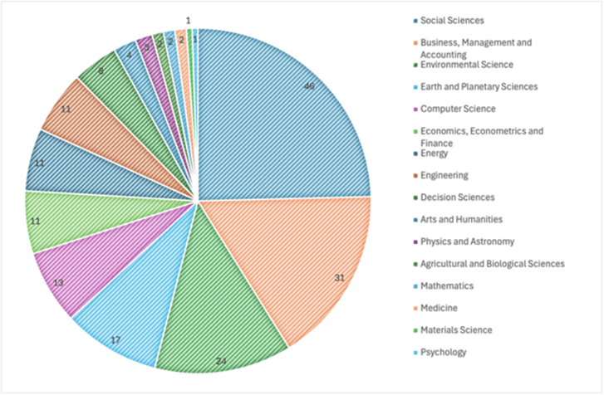
Fig 3: The distribution of publications across different subject areas
The findings of this bibliometric analysis underscore the markedly interdisciplinary nature of the field under investigation. The preponderance of Social Sciences publications suggests that societal and human factors are central to the research domain, potentially reflecting the significance of social implications, policy frameworks, and behavioral aspects. This aligns with contemporary scholarly discourse recognizing the necessity of integrating social dynamics into the investigation of complex phenomena.
The substantial representation of Business, Management and Accounting literature indicates a strong focus on practical implementation and organizational dimensions. This may signify an emphasis on the operationalization of theoretical constructs, potentially encompassing research on business models, management strategies, and economic feasibility studies.
The noteworthy contribution from Environmental Science underscores the ecological dimensions of the research area. This likely reflects the growing academic interest in sustainability and environmental impact assessment, suggesting that the field is intrinsically linked to addressing pressing environmental challenges.
The significant presence of Earth and Planetary Sciences, coupled with contributions from Engineering and Materials Science, points to the importance of understanding and leveraging the physical and technological aspects of the research topic. This interdisciplinary integration suggests that the field is not solely concerned with theoretical frameworks but also with applied solutions that may involve innovative technologies or methodologies.
The diversity of disciplines represented, including smaller but notable contributions from fields such as Arts and Humanities, Mathematics, and Medicine, further accentuates the complexity of the research domain. This breadth of academic input suggests that the topic intersects with various aspects of society, technology, and the natural world, necessitating a holistic approach to inquiry and problem-solving.
Based on the findings and analyses, it can be concluded that the interdisciplinary nature revealed from these analyses indicates that the field is addressing complex and multifaceted issues that require examination through various academic lenses. This diversity of scholarly perspectives is likely to foster innovation and comprehensive understanding within the research area, potentially resulting in more robust and applicable solutions to the challenges at hand. Further research can benefit from this explicitly interdisciplinary approach to develop an integrated framework and methodology.
Key Contributors and Institutions
Most Productive Authors
The bibliometric analysis, encompassing 93 documents and 253 authors, reveals notable disparities in research impact as measured by the H-index (Table 1). Three researchers—ANSELMI P, CASTIGLIONI C, and LOZZA E—emerge as the most influential contributors, each achieving an H-index of 2. This metric, represented visually by dark blue circles at the 2.0 mark on the x-axis, indicates that these authors have at least two publications that have been cited a minimum of twice. In contrast, the remaining authors examined (AKSOVIC N, ALEMPIJEVIC R, AMICARELLI V, AMRI I, ANDREEVA M, ANTONKIEWICZ J, and ANZALDÚA-SOULÉ KR) exhibit an H-index of 1, denoted by light blue circles at the 1.0 mark. While the H-index serves as a valuable indicator of both productivity and impact, it is crucial to acknowledge its limitations. A comprehensive evaluation of scholarly contribution necessitates consideration of additional factors, including total publication output, the innovative content of research, and broader influence within the field that may not be fully captured by citation metrics alone. This multifaceted approach provides a more nuanced understanding of an author's impact on the scholarly landscape.
Table 1. Top authors by number of publications
Leading Institutions
Table 2 reveals that there is a complex and diverse landscape of institutional contributions to the topic. This analysis provides valuable insights into the global distribution of research efforts and the multidisciplinary nature of the field.
Table 2. List of top institutions based on research output
Foremost among the contributing institutions is the Università Cattolica del Sacro Cuore, with approximately seven articles, closely followed by the University of Bari with six. This concentration of research output in Italian institutions suggests a potential regional hub of expertise in this domain. However, the geographic diversity of the contributing institutions is noteworthy, encompassing entities from Europe, North and South America, Asia, and Oceania. This global distribution underscores the universal relevance and growing international interest in sustainable tourism education.
The institutional diversity represented in the data is particularly striking. The list comprises a heterogeneous mix of general universities, specialized institutions such as the Hugo Kołłątaj University of Agriculture, and economics-focused entities like The Bucharest University of Economic Studies. This variety indicates a multifaceted approach to the subject, potentially fostering interdisciplinary insights that could significantly enrich the field.
An examination of the research output distribution reveals a clear gradient, with a few institutions producing significantly more articles than others. The majority of listed institutions have published between two and four articles, suggesting a moderate but consistent engagement with the topic across numerous academic centers. This pattern may indicate an emerging field of study that is gaining traction across various institutional contexts.
Of particular interest is the representation of institutions from both developed and developing nations. The presence of entities such as the Universidad Nacional Autónoma de México and Universitas Negeri Semarang alongside more established research centers points to the emergence of new research hubs and a growing global interest in the intersection of sustainability, tourism, and vocational education.
The diverse array of contributing institutions presents significant opportunities for international collaborations and knowledge exchange. Such partnerships could potentially accelerate the development of comprehensive and innovative approaches to Green Jobs education in the tourism sector.
In terms of implications for curriculum design, the involvement of institutions with varying specializations (agricultural, technological, economic) suggests that an interdisciplinary approach may be beneficial. Curriculum developers may find value in incorporating elements from various fields of study to create comprehensive educational programs that address the multifaceted nature of Green Jobs in tourism.
Table 2 reveals that there is a complex and diverse landscape of institutional contributions to the topic. This analysis provides valuable insights into the global distribution of research efforts and the multidisciplinary nature of the field.
Based on this analysis, it can be concluded that there is a geographically diverse and interdisciplinary research landscape for Green Jobs in tourism vocational education. The prominence of certain institutions, especially in Italy, indicates potential centres of expertise, while the global spread of contributing institutions underlines the universal relevance of this topic. These findings can inform future research directions, facilitate potential collaborations, and guide the development of a holistic approach to curriculum design in this evolving field.
Most Influential Journals
The bibliometric analysis of the top 10 sources pertaining to Green Jobs in tourism expertise for Vocational High Schools reveals a diverse and evolving research landscape (table 3). SUSTAINABILITY (SWITZERLAND) emerges as the most influential publication, boasting the highest h-index (3), g-index (5), and total citations (41), indicative of its substantial impact in the field. This journal's broad scope encompasses various sustainability issues, including tourism, making it a cornerstone for research in this domain. Other notable sources such as DEVELOPMENT SOUTHERN AFRICA and E3S WEB OF CONFERENCES demonstrate moderate impact factors, with the latter exhibiting a particularly high m-index (0.5), suggesting rapid growth in citations since its inception in 2021. The INTERNATIONAL JOURNAL OF GEOHERITAGE AND PARKS, despite its specialized focus, shows promising metrics with a high m-index and total citation count, underscoring the relevance of geoheritage to the green jobs discourse in tourism.
Table 3. Top journals publishing research in this field
The analysis further reveals a geographic diversity in research origins, with journals from various regions contributing to the discourse. This includes publications from Southern Africa, Venezuela, and Brazil, offering valuable localized perspectives on the global issue of green jobs in tourism. The temporal distribution of publication start dates, predominantly post-2017, indicates that this is an emerging area of scholarly inquiry. The presence of conference proceedings (E3S WEB OF CONFERENCES) among the top sources highlights the dynamic nature of the field, where current research and discussions are actively shaping the knowledge base. Moreover, the inclusion of journals from adjacent fields such as economics (AMFITEATRU ECONOMIC) and infrastructure (BUILDINGS) demonstrates the interdisciplinary nature of the topic, encompassing aspects of sustainability, tourism management, economics, and built environment studies. This multifaceted approach to the subject matter suggests a comprehensive examination of green jobs in tourism, considering various dimensions that could inform vocational education strategies. The amalgamation of established sustainability journals with specialized tourism publications provides a robust foundation for research, combining overarching sustainability principles with sector-specific insights crucial for developing targeted vocational programs in green tourism jobs.
Thematic Analysis and Conceptual Structure
Keyword Co-occurrence Analysis
The keyword co-occurrence analysis that shown on Figure 4, based on 93 documents with 75 keywords meeting the minimum occurrence threshold of 2, provides a comprehensive overview of the research landscape in Green Jobs and sustainable tourism within vocational education.
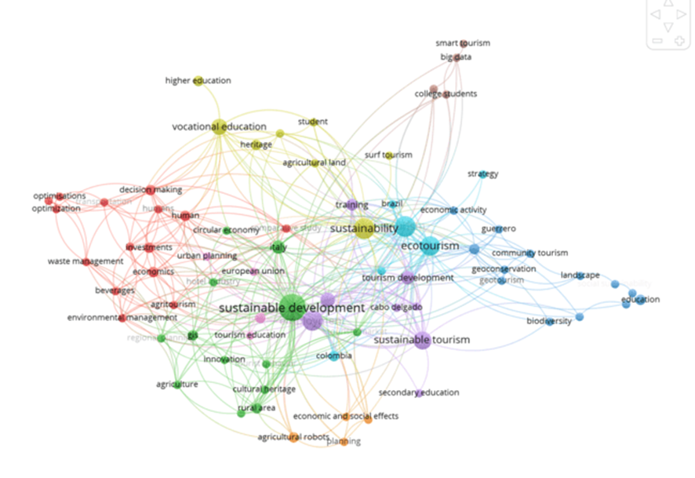
Fig 4: Network visualization of keyword co-occurrence
Scope and Density
The fact that 75 keywords met the minimum occurrence threshold from just 93 documents indicates a rich and diverse vocabulary within this field. This suggests that the research area is multifaceted and possibly still evolving, with many concepts being explored but not yet consolidated into a few dominant themes.
Cluster Identification and Analysis
- Sustainable Development Cluster: This is the largest and most central cluster, anchored by "sustainable development" and "sustainable tourism". Its central position and size indicate that sustainability is the core concept driving research in this field. The strong connections to other clusters suggest that researchers are actively exploring how sustainable development principles can be applied across various aspects of tourism and education.
- Ecotourism and Conservation Cluster: This prominent cluster, including terms like "ecotourism", "biodiversity", and "geoconservation", reflects a strong focus on nature-based tourism and environmental protection. Its size and connections suggest that ecological considerations are a major component of Green Jobs in tourism.
- Vocational Education Cluster: The presence of this distinct cluster, including "vocational education", "higher education", and "training", underscores the importance of educational aspects in the research. Its connections to other clusters indicate efforts to integrate sustainability and green job skills into educational curricula.
- Economic and Planning Cluster: This cluster, featuring terms like "circular economy" and "urban planning", shows that researchers are considering the broader economic and structural implications of sustainable tourism. The presence of "decision making" in this cluster suggests a focus on policy and management aspects.
- Agricultural and Rural Tourism Cluster: The emergence of this cluster indicates a significant focus on rural and agricultural dimensions of sustainable tourism, possibly reflecting efforts to diversify tourism offerings and support rural development through green initiatives.
- Cultural Heritage Cluster: This cluster highlights the integration of cultural preservation with sustainable tourism, suggesting research on how Green Jobs can contribute to both environmental and cultural sustainability.
- Smart Tourism and Technology Cluster: Although smaller, this cluster's presence indicates an emerging interest in technological solutions for sustainable tourism, potentially opening new avenues for Green Jobs.
Interconnections and Gaps
The visualization shows strong interconnections between clusters, particularly through the central sustainable development node. However, some potential gaps are evident:
- Limited direct connections between the vocational education cluster and newer concepts like smart tourism or circular economy, suggesting potential areas for future research integration.
- Relatively small presence of specific green skills or job roles, indicating a possible need for more targeted research on the practical aspects of Green Jobs in tourism.
Emerging Trends
The presence of terms like "big data" and "smart tourism" suggests emerging trends towards digitalization and data-driven approaches in sustainable tourism, which could influence future Green Job requirements and training needs.
This keyword co-occurrence analysis reveals a research field that is diverse, interconnected, and evolving. It emphasizes the multidisciplinary nature of Green Jobs in tourism, spanning environmental, educational, economic, cultural, and technological dimensions. The central role of sustainability concepts suggests a holistic approach to research, while the emergence of technology-related terms indicates future directions for the field.
Trend Topics Over Time
Based on the timeline visualisation (shown in figure 5), we can analyse the thematic evolution of research from 2016 to 2022. The following are topics that have emerged and topics that have declined in prominence:
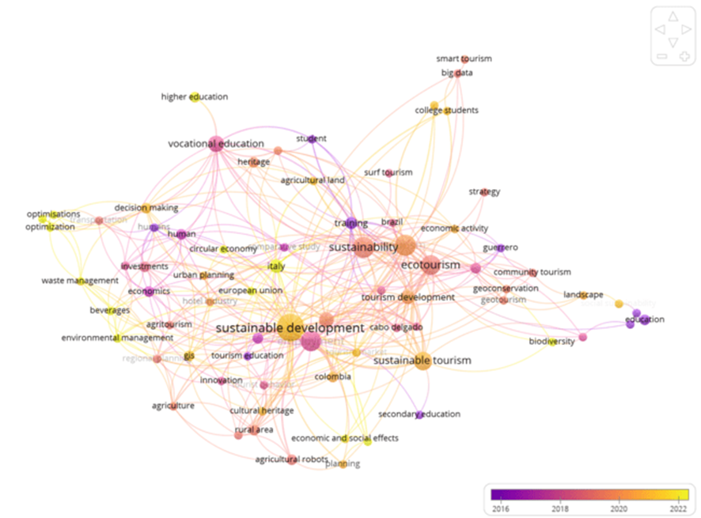
Fig 5: Thematic evolution map showing how research themes have changed

- Emerging Topics (2020-2022)
  - Smart Tourism and Big Data: These concepts appear in yellow, indicating they are recent additions to the research landscape. This suggests an increasing focus on technological solutions and data-driven approaches in sustainable tourism.
  - College Students: The emergence of this keyword suggests a growing interest in higher education's role in preparing the future workforce for green jobs in tourism.
  - Surf Tourism: This niche area of tourism appears as a newer topic, possibly indicating an expansion of sustainable tourism research into specific recreational sectors.
  - Economic Activity and Strategy: These terms appear in warmer colors, suggesting recent increased attention to the economic aspects and strategic planning of sustainable tourism.
  - Guerrero: This could refer to a specific region or case study that has gained recent attention in sustainable tourism research.
- Topics Maintaining or Gaining Prominence
  - Sustainable Development and Sustainable Tourism: These central concepts remain prominent throughout the timeline, indicated by their large size and central position.
  - Ecotourism: This topic appears to have maintained its importance over the years, with consistent research attention.
  - Vocational Education: While not new, this topic seems to have maintained its relevance, suggesting ongoing interest in skills development for green jobs.
- Topics Declining in Prominence (2016-2018)
  - Environmental Management: This term appears in a cooler color, suggesting it was more prominent in earlier research but has become less central in recent years.
  - Waste Management: Similar to environmental management, this specific aspect seems to have received more attention in earlier years.
  - Optimizations: This more technical term appears in cooler colors, possibly indicating a shift from theoretical optimizations to more practical applications in recent research.
  - GIS (Geographic Information Systems): While still present, this tool seems to have been more prominently featured in earlier research.
- Evolving Themes
  - Agriculture and Rural Areas: These topics appear to have evolved over time, with related concepts like "agricultural land" and "agritourism" appearing in various colors, suggesting ongoing but evolving research interest.
  - Cultural Heritage: This theme seems to have maintained relevance throughout the period, evolving to connect with newer concepts of sustainable tourism.
  - Education: The evolution from "secondary education" to "higher education" and "college students" suggests a shift in focus towards higher levels of education in preparing for green jobs in tourism.
This thematic evolution map demonstrates a clear shift towards more technologically advanced, economically focused, and strategically oriented research in sustainable tourism and green jobs. There's an apparent move from broader environmental management concepts to more specific, actionable areas like smart tourism and data-driven approaches. The consistent prominence of sustainable development and ecotourism underscores their foundational role in this research field, while the emergence of new niche areas like surf tourism indicates an expanding and diversifying research landscape.
Conceptual Structure Mapping
The Conceptual Structure Map provides a comprehensive visualisation of the research landscape around green jobs in the field of tourism expertise in the context of vocational education, as can be seen in figure 6. The analysis reveals a multifaceted and evolving field of study. Core themes prominently situated within the map include tourism development, vocational education, and economic impacts, indicating their centrality to the discourse. These foundational areas are complemented by emerging themes such as international cooperation, sustainable development, and environmental management, which are strategically positioned to suggest their growing significance in the field. The map also illuminates potentially established or declining themes, including ecotourism and rural area studies, which, while still relevant, may not be at the forefront of current research trajectories. Of particular interest are the niche or specialized areas identified, such as the integration of agricultural robotics and vehicle routing optimization, which may represent innovative intersections between technology and sustainable tourism practices.
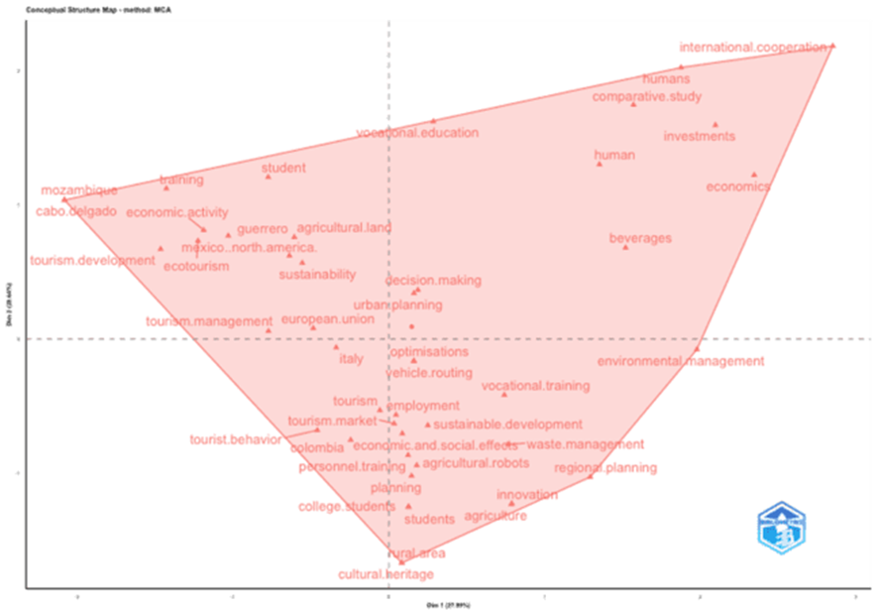
Fig 6: Conceptual Structure Map
The presence of geographically diverse terms (e.g., Mozambique, Mexico, Colombia) underscores the global nature of the research, encompassing various regional case studies and comparative analyses. Furthermore, the map highlights the importance of human factors, as evidenced by the inclusion of terms related to students, tourist behavior, and human resources. This comprehensive thematic distribution reflects the interdisciplinary nature of the field, integrating elements of tourism studies, educational theory, economics, environmental science, and technological innovation. The spatial relationships between these concepts provide valuable insights into the current state of research, suggesting potential areas for future investigation and emphasizing the complex, interconnected nature of green jobs in tourism within the broader context of vocational education and sustainable development.
Citation Analysis and Intellectual Structure
Most Cited Papers
An analysis of the most cited papers in the field of green jobs in tourism and vocational education reveals a diverse range of influential works that have significantly shaped the discourse. These publications span various aspects of tourism management, sustainability and regional development, demonstrating the multidisciplinary nature of this research area (table 4).

Table 4. The most cited papers in the field
The work of (Pasquale Del Vecchio et al., 2017) in the Journal of Destination Marketing & Management emerges as the most cited paper with 56 total citations, suggesting its substantial impact on the field. This is closely followed by Ponting (Ponting & O’Brien, 2015) publication in Sport Management Review, with 55 citations. Both papers demonstrate consistent influence over time, as evidenced by their high citation rates per year (7 and 5.5, respectively). (Kronenberg & Fuchs, 2021) more recent contribution in Tourism Management Perspectives has quickly gained traction, accumulating 36 citations in a short period and boasting the third-highest normalized citation count (6.29), indicating its immediate relevance and potential to shape future research directions.
Notably, (Samal & Dash, 2023) publication in the International Journal of Geoheritage and Parks, despite its recency, has garnered significant attention with the highest citation rate per year (14) and normalized citation count (9.06). This suggests a growing interest in geoheritage and its intersection with sustainable tourism practices. Conversely, older publications such as (Birrell & Perry, 2009) work in People Place and (Castro & Brignardello, 2005) contribution to Revista Geográfica del Norte Grande, while less frequently cited annually, have maintained their relevance over time, indicating their foundational role in the field.
The presence of publications from journals focusing on transportation ((Ignaccolo et al., 2020), sustainability (Deaconu et al., 2018), and geosciences (Meini et al., 2018) underscores the interdisciplinary approach necessary for comprehensively addressing green jobs in tourism. This diversity in influential works reflects the complex interplay of environmental, economic, and social factors that characterize the sustainable tourism sector and its implications for vocational education.
The analysis of these highly cited papers provides valuable insights into the evolving landscape of research on green jobs in tourism and vocational education. It highlights key areas of focus, emerging trends, and enduring concepts that continue to shape the field, offering a robust foundation for future studies and practical applications in sustainable tourism development and related educational programs.
Co-citation Network
The co-citation network visualisation in Figure 7 illuminates the intellectual structure and theoretical underpinnings of research on green jobs in tourism and vocational education. It reveals a complex and interconnected landscape of scholarly thinking. The most prominent network cluster, anchored by the important works of Arie (1999, 2015), Wilson (2013), Flohr (2001), Tribe (2002), and Dredge (2012), represents a core school of thought that likely encompasses foundational concepts in tourism education and curriculum development (Airey et al., 2015; Airey & Johnson, 1999; Therivel et al., 2013). This central cluster's cohesiveness suggests a well-established theoretical framework that has evolved over time, as evidenced by Airey's sustained influence across multiple publications. Adjacent to this core, two smaller clusters emerge: one comprising Sheldon and Schweinsberg (both 2013), potentially representing more recent developments in sustainable tourism practices, and another linking Mafunzwaini (2005) and Ashley (2002), which may offer longitudinal perspectives on tourism development in specific regional or economic contexts.
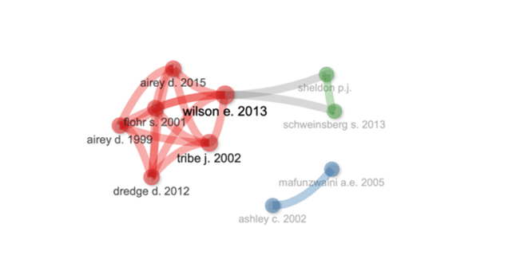
Fig 7: Co-citation network
The network's structure reveals notable patterns, including a clear temporal evolution of the field, with newer works building upon earlier foundational studies. Wilson's (2013) work appears to serve as a critical bridge between theoretical approaches, suggesting its integrative role in the field. The presence of isolated contributions, such as those by Mafunzwaini and Ashley, indicates the field's capacity to accommodate niche perspectives or specialized areas of inquiry. This co-citation analysis thus portrays a multifaceted research domain characterized by a dominant theoretical framework, complemented by emerging or specialized approaches. The interconnectedness of these clusters reflects the field's multidisciplinary nature, integrating elements of educational theory, tourism management, sustainability studies, and regional development. This rich intellectual tapestry underscores the complex interplay of ideas shaping the discourse on green jobs in tourism and vocational education, suggesting a field that is both grounded in established theories and receptive to new perspectives and cross-disciplinary insights.
Historiograph Analysis
Table 5 shows the intellectual evolution of green jobs in tourism expertise for vocational education revealing a dynamic and diverse field that has responded to global trends and emerging challenges over the past two decades. Initially centered on environmental education, as evidenced by Wade's seminal 1999 work on students as environmental change agents (Wade, 1999), the field gradually expanded to incorporate geomorphological applications in coastal management, exemplified by Castro's 2005 study (Castro & Brignardello, 2005). A significant shift occurred in the late 2000s, marked by Birrell's 2009 research on immigration policy and the international student industry, which broadened the scope to include policy and economic dimensions (Birrell & Perry, 2009).
Table 5. Historiography the evolution of key ideas over time
This trend culminated in Ponting's highly influential 2015 paper on regulating sustainable surf tourism, effectively bridging environmental concerns with economic and policy considerations (Ponting & O’Brien, 2015). The field subsequently embraced technological advancements and smart specialization strategies, as demonstrated by (P Del Vecchio & Passiante, 2017) work while simultaneously diversifying into areas such as geotourism (Meini et al., 2018) and urban mobility (Ignaccolo et al., 2020). Recent years have witnessed a concerted effort to align tourism education with global sustainability objectives, epitomized by (Kronenberg & Fuchs, 2021) study on linking tourism's socio-economic impact with UN Sustainable Development Goals, and (Samal & Dash, 2023) research on ecotourism and biodiversity conservation. Throughout this evolution, the field has maintained a consistent focus on vocational education, adapting its approaches to incorporate emerging themes such as digital skills, sustainable practices, and global development imperatives. This trajectory underscores the field's resilience and adaptability, evolving from a primarily environmental focus to a complex, interdisciplinary domain that integrates technological innovation, urban planning, economic development, and global sustainability initiatives, all while preserving its core emphasis on practical, vocational training. The field's intellectual development reflects its responsiveness to global challenges and its increasing alignment with broader sustainable development objectives, positioning it at the nexus of education, tourism, and sustainability studies.
Implications for Curriculum Development and Policy-Making
Identified Skill Gaps
A thematic analysis of the literature on Green Jobs in tourism vocational education (previous section) revealed a spectrum of skills that feature prominently in current research, while also highlighting areas that appear to be underrepresented. Sustainability competencies and ecotourism management skills emerged as key themes, reflecting the field's primary focus on environmental stewardship and responsible tourism practices. Cultural heritage management, agricultural and rural tourism skills, and environmental management also emerged prominently, underlining the multifaceted nature of sustainable tourism education. The literature further emphasises economic and business skills within a sustainability framework, as well as strategic planning and decision-making capabilities, indicating recognition of the need to balance ecological concerns with economic viability.
However, the analysis also reveals several skill areas that appear to be underrepresented in the current body of research. Notably, there is a paucity of focus on specific green technology skills and climate change adaptation strategies, despite their increasing relevance to the tourism sector. Soft skills tailored to sustainable tourism contexts, such as cross-cultural communication and ethical decision-making, also receive limited attention. Similarly, green marketing, sustainable supply chain management, and community engagement skills are not as prominently featured as one might expect given their importance in implementing sustainable tourism practices. The apparent lack of emphasis on green entrepreneurship skills and sustainability monitoring and reporting competencies suggests potential gaps in preparing students for the full spectrum of challenges in the evolving green tourism landscape.
Moreover, the emergence of digital skills related to smart tourism and big data analysis in recent literature indicates a growing recognition of the role of technology in sustainable tourism management. However, this trend also highlights the need for more comprehensive research on integrating these digital competencies with traditional sustainability skills. The underrepresentation of crisis management skills in the context of sustainable tourism is particularly noteworthy, especially in light of recent global events that have significantly impacted the tourism industry.
This analysis suggests that while current research in Green Jobs and tourism vocational education covers a broad range of relevant skills, there are substantial opportunities to expand the focus to include more specific, technical, and emerging skill sets. Future research and curriculum development initiatives in this field would benefit from addressing these identified gaps, ensuring a more comprehensive and forward-looking approach to preparing the workforce for the evolving demands of sustainable tourism. Such efforts would not only enhance the relevance and effectiveness of vocational education programs but also contribute to the broader goals of sustainable development within the tourism sector.
Policy Recommendations
The analysis of research trends in Green Jobs within tourism vocational education suggests several policy directions that could effectively promote this field, particularly for vocational education institutions and tourism-focused vocational high schools. These policy recommendations are grounded in the observed trends and aim to address both current needs and emerging challenges in the sector.
A primary focus should be on the comprehensive integration and modernization of curricula. Policies should mandate the incorporation of sustainability principles across all aspects of tourism vocational education, reflecting the evolving nature of the field. This integration should encompass emerging topics such as smart tourism, big data analytics, and the Sustainable Development Goals. Furthermore, policies should establish mechanisms for regular curriculum updates to ensure alignment with the latest sustainable tourism practices and green job skill requirements.
The development of robust industry-education partnerships emerges as another crucial policy direction. Such policies should foster collaborative relationships between vocational institutions and sustainable tourism enterprises, facilitating experiential learning opportunities such as internships, expert-led guest lectures, and joint research initiatives. These partnerships are instrumental in ensuring that the skills imparted through vocational education closely align with the current and projected needs of the green job market in tourism.
Given the increasing significance of digital technologies in sustainable tourism, policies should prioritize the enhancement of digital competencies within vocational education programs. This could involve the establishment of specialized courses focusing on digital applications in sustainable tourism and the provision of requisite infrastructure for practical, hands-on learning experiences with these technologies.
To address the multifaceted nature of sustainable tourism, policies should promote an interdisciplinary approach to education. This could entail the development of collaborative programs between tourism departments and other relevant disciplines such as environmental science, cultural studies, and business management. Such an approach would better prepare students for the diverse challenges they may encounter in green tourism jobs.
Continuous professional development of educators should also be a key policy focus. Implementing mandatory training programs, facilitating attendance at relevant conferences, and providing industry immersion experiences for teachers would ensure that instructors remain at the forefront of sustainable tourism practices and can effectively impart this knowledge to their students.
To address identified gaps in the research landscape, policies should be implemented to incentivize research in underrepresented areas of green jobs in tourism. This could include the establishment of research grants, recognition programs, or the integration of research components into vocational curricula, with a particular focus on areas such as specific green technologies, climate change adaptation strategies, and crisis management in sustainable tourism contexts.
The development of standardized certification for green skills in tourism vocational education represents another important policy direction. These certifications should align with international sustainability frameworks and be subject to regular updates to reflect evolving industry needs. Such standards would not only ensure consistency in education quality but also enhance the employability of graduates in the global green tourism market.

Policies encouraging green entrepreneurship within tourism vocational education could significantly contribute to innovation in the sector. This might involve the integration of entrepreneurship modules into existing curricula, the provision of mentorship programs, and the establishment of seed funding initiatives for sustainable tourism ventures initiated by students.
Finally, policies facilitating international collaborations in tourism vocational education should be considered. These could encompass student exchange programs, international internships, or joint curriculum development initiatives with institutions in countries at the forefront of sustainable tourism research and practice. Such international exposure would broaden students' perspectives and enhance their ability to operate in the global sustainable tourism landscape.
By implementing these policy directions, vocational education institutions and tourism-focused vocational high schools can better align their programs with the evolving landscape of green jobs. This alignment will ensure that graduates are well-equipped to contribute to and lead in sustainable tourism practices, ultimately fostering a more resilient and environmentally conscious tourism sector.
Curriculum Development Insights
The identified themes and trends in Green Jobs research within tourism vocational education provide a robust framework for informing curriculum design in Vocational High Schools. The centrality of sustainability and sustainable development in the research landscape necessitates their integration as foundational elements across all aspects of the curriculum, rather than as isolated modules. This holistic approach should encompass key themes such as ecotourism, cultural heritage management, and smart tourism, reflecting the multifaceted nature of sustainable tourism practices. The curriculum should also address the growing importance of digital skills, as evidenced by the emergence of smart tourism and big data analytics in recent research. Furthermore, the consistent presence of economic and planning-related themes underscores the need for strong business and strategic planning components, including sustainable business models, green finance, and circular economy principles. The evolving focus on agricultural and rural tourism, as well as the underrepresented yet critical areas of climate change adaptation and environmental management, should also be incorporated to ensure a comprehensive educational approach.
For example, the Blue Mountains International Hotel Management School in Australia has successfully integrated sustainability principles across its curriculum. Their program includes modules on sustainable resource management, eco-friendly hospitality practices, and green event planning. This holistic approach has resulted in graduates who are well-prepared for green jobs in the tourism sector, with 85% of alumni reporting that they apply sustainability practices in their current roles.
To address the gaps identified in the research, curricula should place greater emphasis on soft skills development, including cross-cultural communication and ethical decision-making in tourism contexts. The notable absence of crisis management skills in current research highlights an area for significant curriculum enhancement, particularly in light of recent global events affecting the tourism sector. Additionally, the interdisciplinary nature of the field suggests that curricula should adopt an integrated approach, potentially through collaborative projects that synthesize multiple domains of sustainable tourism practice. By aligning curriculum design with these identified themes and trends, Vocational High Schools can ensure that their tourism programs remain relevant, comprehensive, and forward-looking, equipping students with the diverse skill set required to navigate the complex landscape of sustainable tourism and contribute meaningfully to the growth of green jobs in the sector. Regular curriculum reviews and updates will be essential to keep pace with the rapidly evolving field of sustainable tourism and ensure that vocational education continues to meet industry needs and sustainability goals.
Crisis Management and Resilience
Given the recent global events, particularly the COVID-19 pandemic, there is a pressing need to incorporate crisis management and resilience-building skills into tourism vocational education curricula. Future research should explore how these skills can be effectively integrated into green jobs training programs, preparing students to navigate unforeseen challenges while maintaining a focus on sustainability.
The COVID-19 pandemic highlighted the critical need for crisis management skills in tourism education. For instance, the Escola Universitària d'Hoteleria i Turisme de Barcelona quickly adapted its curriculum in 2020 to include a new module on 'Tourism Resilience and Recovery Strategies'. This proactive approach equipped students with skills to navigate unprecedented challenges in the industry.
Technological Integration
The emerging focus on smart tourism and big data analytics suggests a need for more comprehensive integration of digital skills in vocational education programs. Curriculum developers should consider incorporating modules on data analysis, digital marketing, and the use of emerging technologies in sustainable tourism management.
Specifically, vocational schools should consider incorporating the following technological elements into their curricula:

- Virtual and Augmented Reality (VR/AR) simulations of sustainable tourism practices
- Data analytics courses focusing on interpreting and utilizing big data in sustainable tourism management
- Training on sustainable tourism management software and platforms
- Courses on digital marketing strategies for eco-friendly tourism products and services
- Integration of Internet of Things (IoT) applications for energy and resource management in hospitality settings
These technological integrations will not only enhance the relevance of vocational education programs but also ensure that graduates are well-equipped to leverage cutting-edge technologies in promoting and implementing sustainable tourism practices.
Research Gaps and Future Directions
Underexplored Areas
The bibliometric analysis of Green Jobs in tourism vocational education reveals several underrepresented topics and approaches that warrant further investigation. Notably, there appears to be a dearth of research focusing on specific green technologies and their application in tourism contexts. While smart tourism and big data are emerging themes, there is limited exploration of renewable energy systems, water conservation technologies, and sustainable waste management practices specifically tailored to the tourism industry. Furthermore, the analysis indicates a paucity of studies addressing climate change adaptation strategies within the framework of tourism vocational education. This gap is particularly significant given the increasing vulnerability of many tourism destinations to climate-related risks. Additionally, the bibliometric data suggests an underrepresentation of research on green entrepreneurship skills and sustainable supply chain management within tourism education, areas that are crucial for fostering innovation and comprehensive sustainability in the sector.
Another notable gap in the current research landscape is the limited focus on crisis management and resilience building in sustainable tourism education. The recent global events, particularly the COVID-19 pandemic, have underscored the importance of these skills, yet they remain underexplored in the context of green jobs and vocational training. Moreover, the analysis reveals a scarcity of studies examining the integration of Indigenous knowledge and practices into sustainable tourism education, an area that could significantly enhance cultural sustainability and community engagement. The bibliometric data also indicates an underrepresentation of research on monitoring, measuring, and reporting sustainability performance in tourism, skills that are increasingly demanded by the industry but appear to be overlooked in current vocational education research.
Methodological Gaps
The bibliometric analysis, while providing valuable insights, reveals several methodological gaps that merit attention in future research endeavors. These gaps not only highlight limitations in the current body of knowledge but also present opportunities for enhancing the rigor and comprehensiveness of research in this field. Firstly, there is a notable paucity of mixed-methods approaches in the examined literature. The predominance of either purely quantitative or qualitative methodologies limits the depth and breadth of understanding in this complex field. Integration of both quantitative and qualitative methods could provide a more nuanced comprehension of the multifaceted nature of Green Jobs in tourism vocational education. Additionally, the analysis reveals a lack of longitudinal studies, which are crucial for understanding the evolving nature of skills requirements and the long-term impact of vocational education on sustainable tourism practices.
This gap impedes our understanding of how Green Jobs and related educational needs transform over time in response to technological advancements and shifting environmental priorities. Furthermore, there is a noticeable absence of action research methodologies, which could be particularly beneficial in bridging the gap between theory and practice in vocational education settings. The lack of participatory research approaches also represents a significant methodological gap, potentially limiting the inclusion of key stakeholders' perspectives, especially those of students, educators, and industry practitioners, in shaping Green Jobs curricula and policies.
To address these methodological limitations, future research should:
- Design mixed-methods studies that combine quantitative surveys with in-depth qualitative interviews to provide a more comprehensive understanding of green jobs in tourism education.
- Conduct longitudinal studies tracking cohorts of students from vocational education through their early career years to assess the long-term impact of green jobs training.
- Implement action research projects where researchers collaborate with vocational schools to develop and test innovative green jobs curricula.
- Utilize participatory research methods to involve key stakeholders (students, educators, industry professionals) in the research process, ensuring that findings are relevant and applicable to real-world contexts.

Suggestions for Future Research
Based on these identified gaps and methodological limitations, several promising avenues for future research emerge. Firstly, future studies should prioritize longitudinal research designs that track the evolution of Green Jobs skills requirements and the long-term impact of vocational education on sustainable tourism practices. Such studies could provide valuable insights into the efficacy of current educational approaches and inform curriculum adaptations to meet evolving industry needs. Additionally, cross-cultural comparative research is strongly recommended to examine how different geographical, cultural, and economic contexts influence the implementation and outcomes of Green Jobs education in tourism.
This could lead to a more nuanced understanding of best practices and context-specific challenges, facilitating the development of more adaptable and globally relevant educational models. Furthermore, researchers should explore the integration of emerging technologies and their implications for Green Jobs in tourism. This could include studies on the application of artificial intelligence, virtual and augmented reality, and blockchain technology in sustainable tourism practices and how these can be effectively incorporated into vocational education curricula. Interdisciplinary research collaborations between tourism scholars, environmental scientists, and education specialists are encouraged to develop holistic approaches to Green Jobs education that align with the complex, multifaceted nature of sustainable tourism.
There is also a critical need for research that examines the role of vocational education in fostering resilience and adaptability in the tourism workforce, particularly in the context of global challenges such as climate change and pandemics. Such research could significantly contribute to enhancing the preparedness of the tourism sector for future disruptions while maintaining a focus on sustainability and green employment. Lastly, future studies should investigate the impact of global events, such as the COVID-19 pandemic, on the evolution of green jobs in tourism and the necessary adaptations in vocational education. This line of inquiry could provide crucial insights into the dynamic nature of the field and inform the development of more resilient and adaptive educational strategies for preparing the future workforce in sustainable tourism.
Future studies should prioritize cross-cultural comparative research to examine how different geographical, cultural, and economic contexts influence the implementation and outcomes of Green Jobs education in tourism. This approach could provide valuable insights into:
  - How various cultural perspectives shape the understanding and implementation of sustainable tourism practices
  - The effectiveness of different educational models across diverse economic settings
  - Region-specific challenges and opportunities in developing green jobs in tourism
  - Best practices that can be adapted or replicated across different cultural contexts
Such research would not only enhance our understanding of global trends in Green Jobs education but also facilitate the development of more adaptable and culturally sensitive vocational training programs.

Conclusion
This bibliometric analysis of Green Jobs in tourism vocational education offers a comprehensive overview of the current research landscape, revealing significant trends, gaps, and future research opportunities. The study highlights the growing integration of sustainability principles across tourism education, with particular emphasis on ecotourism, cultural heritage management, and smart tourism technologies. It also underscores the increasing importance of digital skills and data analytics in sustainable tourism management. However, the analysis identifies notable gaps, including underrepresentation of research on specific green technologies, climate change adaptation strategies, and crisis management skills.
Methodological limitations, such as a lack of longitudinal studies and limited use of mixed-methods approaches, are also evident. These findings have significant implications for curriculum design in vocational schools and policy development in sustainable tourism education, suggesting a need for more holistic, technology-integrated, and adaptable educational approaches. The study concludes that as the tourism industry evolves in response to global environmental and social challenges, vocational education plays a crucial role in shaping a skilled, adaptable, and sustainability-focused workforce. Future research should address the identified gaps, particularly in emerging technologies, cross-cultural comparisons, and the long-term impacts of Green Jobs education in tourism, to enhance our understanding of effective educational strategies in this dynamic and interdisciplinary field.

References
Acampora, A., Daddi, T., Merli, R., & Preziosi, M. (2018). From linear to circular tourism: The case study of an Italian Ecologically Equipped Productive Area. Proceedings of the 24th International Sustainable Development Research Society (ISDRS) Conference, Messina.
Agustin, H., Hidayat, D. R., & Sirait, R. A. (2018). The Ignorance of Coral Reefs Conservation Content on Tourism Vocational High School Curriculum in Pangandaran.
Airey, D., & Johnson, S. (1999). The content of tourism degree courses in the UK. Tourism Management, 20(2), 229–235.
Airey, D., Tribe, J., Benckendorff, P., & Xiao, H. (2015). The managerial gaze: The long tail of tourism education and research. Journal of Travel Research, 54(2), 139–151.
Alvarez-Risco, A., Estrada-Merino, A., & Perez-Luyo, R. (2020). Sustainable development goals in hospitality management. In Sustainable Hospitality Management: Designing Meaningful Encounters With Talent and Technology (pp. 159–178). Emerald Publishing Limited.
Angiola, N., Bianchi, P., & Corvino, A. (2015). The integration of best environmental management practices in corporate strategy: Empirical evidence from Italian local governments. International Journal of Public Administration, 38(7), 510–520.
Ariyanto, A. (2022). Green Tourism Management for Sustainable Tourism Development in the Age of Disruption. Jurnal Multidisiplin Sahombu, 2(1), 23–28.
Asnawi, R., & Djatmiko, I. W. (2015). A challenge of vocational education for preparing green employment. 3rd UPI International Conference on Technical and Vocational Education and Training, 175–178.
Birrell, B., & Perry, B. (2009). Immigration policy change and the international student industry. People and Place, 17(2), 64–80. https://www.scopus.com/inward/record.uri?eid=2-s2.0-68949151887&partnerID=40&md5=1d9e6e2f162dd4263540b4d24a2f0208
Castro, C., & Brignardello, L. (2005). Geomorphology applied to plan of use of sandy coastal areas. Indications for the protection and sustainable use of in Los Choros, IV region. Revista de Geografia Norte Grande, 33, 33–58. https://www.scopus.com/inward/record.uri?eid=2-s2.0-22944474676&partnerID=40&md5=1c3d383c3b0bd425f5a21a7e1944bbfe
Chen, Y., Kangning, X., Zhenzhen, Z., & Chuanze, J. (2020). Visualized Analysis on Research Progress of Tourism Environment Carrying Capacity of World Heritage. Environment, 2(5), 11–18.
Christoff, P. (2008). A South Seas Carbon Bubble Australia and a Near-Pacific Regional Climate Pact. Asia Pac. J. Envtl. L., 11, 13.
Coghlan, A. (2019). Challenges to implementing sustainability practices in tourism.
Coll-Ramis, M. À., Horrach-Rosselló, P., Genovart-Balaguer, J., & Martinez-Garcia, A. (2023). Research progress on the role of education in tourism and hospitality. A bibliometric analysis. Journal of Hospitality & Tourism Education, 1–13.
Deaconu, A., Dedu, E., Igreț, R., & Radu, C. (2018). The use of information and communications technology in vocational education and training—Premise of sustainability. Sustainability, 10(5), 1466. https://www.mdpi.com/2071-1050/10/5/1466/pdf
Del Vecchio, P, & Passiante, G. (2017). Is tourism a driver for smart specialization? Evidence from Apulia, an Italian region with a tourism vocation. Journal of Destination Marketing and Management, 6(3), 163–165. https://doi.org/10.1016/j.jdmm.2016.09.005
Del Vecchio, Pasquale, Mele, G., Ndou, V., & Secundo, G. (2017). Open innovation and social big data for sustainability: Evidence from the tourism industry. Sustainability, 10(9), 3215.
Diep, P. C., & Hartmann, M. (2016). Green Skills in Vocational Teacher Education–a model of pedagogical competence for a world of sustainable development. TVET@ Asia, 6, 1–19.
Elkhwesky, Z., Salem, I. E., Varmus, M., & Ramkissoon, H. (2022). Sustainable practices in hospitality pre and amid COVID‐19 pandemic: Looking back for moving forward post‐COVID‐19. Sustainable Development, 30(5), 1426–1448.
Fadeeva, Z., & Mochizuki, Y. (2007). Regional centres of expertise: innovative networking for education for sustainable development. Journal of Education for Sustainable Development, 1(2), 229–237.
Fang, M., Nguyen, T.-H., & Armstrong, A. (2022). Developing collective leadership capacity to drive sustainable practices: Destination case of leadership development in Australia. Journal of Hospitality & Tourism Research, 46(5), 826–845.
Foo, D. C. Y., & Lam, H. L. (2013). Green technologies for Asia–Pacific economies. In Clean Technologies and Environmental Policy (Vol. 15, pp. 747–748). Springer.
Gössling, S. (2021). Tourism, technology and ICT: a critical review of affordances and concessions. Journal of Sustainable Tourism, 29(5), 733–750.
Grizane, T. (2023). Sustainability of Tourism and the Environment. ENVIRONMENT. TECHNOLOGIES. RESOURCES. Proceedings of the International Scientific and Practical Conference, 1, 70–73.
Guillén-Peñafiel, R., Hernández-Carretero, A. M., & Sánchez-Martín, J.-M. (2022). Heritage Education as a Basis for Sustainable Development. The Case of Trujillo, Monfragüe National Park and Villuercas-Ibores-Jara Geopark (Extremadura, Spain). Land, 11(8), 1183.
Gupta, M., & Hasnain, A. (2022). Sustainable tourism: Elevating collaboration between the hospitality industry and local citizens. ECS Transactions, 107(1), 18611.
Haloho, A. A., Pardjono, I. N. S., & Suyitno, B. (2023). Implementation of Green Skills in Vocational Education: Perceptions about Students’ and Teachers’ Behavioral Activities. Jurnal Pendidikan Dan Pengajaran, 56(1), 65–79.
Higgins-Desbiolles, F. (2018). Sustainable tourism: Sustaining tourism or something more? Tourism Management Perspectives, 25, 157–160.
Ignaccolo, M., Inturri, G., Giuffrida, N., Le Pira, M., Torrisi, V., & Calabrò, G. (2020). A step towards walkable environments: Spatial analysis of pedestrian compatibility in an urban context. European Transport - Trasporti Europei, 76. https://www.scopus.com/inward/record.uri?eid=2-s2.0-85087333386&partnerID=40&md5=3096cd5e076f09047818bdbc9c7993c4
Kamis, A., Alwi, A., & Yunus, F. A. (2017). Integration of green skills in sustainable development in technical and vocational education. International Journal of Engineering Research and Applications, 7(12), 8–12.
Kronenberg, K., & Fuchs, M. (2021). Aligning tourism’s socio-economic impact with the United Nations’ sustainable development goals. Tourism Management Perspectives, 39, 100831.
Legrand, W., Sloan, P., Delgado-Krebs, R., & Tooman, H. (2011). Sustainable tourism & hospitality management education: an empirical study on educational experiences in preparation for professional life. In Advances in Hospitality and Leisure (pp. 195–208). Emerald Group Publishing Limited.
Manmohan, C., Nikhat, M., Mohammad, N., Gera, R., & Pathani, A. (2023). Green Technology and Environmental Sustainability in The Tourism Sector: A Bibliometric Analysis. E3S Web of Conferences, 391, 1179.
Meini, M., Di Felice, G., & Petrella, M. (2018). Geotourism perspectives for transhumance routes. Analysis, requalification and virtual tools for the geoconservation management of the drove roads in southern Italy. Geosciences (Switzerland), 8(10). https://doi.org/10.3390/geosciences8100368
Mínguez, C., Martínez-Hernández, C., & Yubero, C. (2021). Higher education and the sustainable tourism pedagogy: Are tourism students ready to lead change in the post pandemic era? Journal of Hospitality, Leisure, Sport & Tourism Education, 29, 100329.
Natuva, C. T. (2021). Fiji’s ‘Blue Economy’and the importance of maritime security. RAN Sea Power Soundings, 23.
Niñerola, A., Sánchez-Rebull, M.-V., & Hernández-Lara, A.-B. (2019). Tourism research on sustainability: A bibliometric analysis. Sustainability, 11(5), 1377.
Osorio, J., & Nieves, J. (2019). Antecedents of sustainable vocational education and training in ICT in global south countries. Sustainable ICT, Education and Learning: IFIP WG 3.4 International Conference, SUZA 2019, Zanzibar, Tanzania, April 25–27, 2019, Revised Selected Papers 1, 157–166.
Pavlova, M. (2018). Fostering inclusive, sustainable economic growth and “green” skills development in learning cities through partnerships. International Review of Education, 64, 339–354.
Ponting, J., & O’Brien, D. (2015). Regulating “Nirvana”: Sustainable surf tourism in a climate of increasing regulation. Sport Management Review, 18(1), 99–110.
Pu, W. U., & Shuai, Y. U. E. (2013). The progress of research into energy use and carbon dioxide emissions from the Chinese tourism industry. Tourism Tribune/Lvyou Xuekan, 28(7).
Samal, R., & Dash, M. (2023). Ecotourism, biodiversity conservation and livelihoods: Understanding the convergence and divergence. International Journal of Geoheritage and Parks, 11(1), 1–20. https://doi.org/10.1016/j.ijgeop.2022.11.001
Seraphin, H., Bah, M., Fyall, A., & Gowreesunkar, V. G. B. (2021). Tourism education in France and sustainable development goal 4 (quality education). Worldwide Hospitality and Tourism Themes, 13(1), 139–147.
Sigala, M. (2020). Tourism and COVID-19: Impacts and implications for advancing and resetting industry and research. Journal of Business Research, 117, 312–321.
Stanef-Puică, M.-R., Badea, L., Șerban-Oprescu, G.-L., Șerban-Oprescu, A.-T., Frâncu, L.-G., & Crețu, A. (2022). Green jobs—A literature review. International Journal of Environmental Research and Public Health, 19(13), 7998.
Stoican, M., Vărvăruc, D., & Filip, N. (2022). Practicing a sustainable tourism in the context of supporting the green economy. 30 Years of Economic Reforms in the Republic of Moldova: Economic Progress via Innovation and Competitiveness, 1, 223–230.
Stojanovska-Stefanova, A., Dimitrov, N., & Magdinceva Sopova, M. (2019). The significant role of the tourism in achieving the United Nations sustainable development goals. Knowledge-International Journal, Scientific Papers, 34(5), 1259–1264.
Sulich, A., & Zema, T. (2018). Green jobs, a new measure of public management and sustainable development. European Journal of Environmental Sciences, 8(1).
Sumbodo, W., Yudiono, H., & Setiadi, R. (2019). The role of industry partners to improving student competency of vocational high school. Journal of Physics: Conference Series, 1387(1), 12031.
Therivel, R., Wilson, E., Heaney, D., & Thompson, S. (2013). Strategic environmental assessment. Routledge.
Ulfah, S. M., Sururi, S., & Amrullah, S. (2020). Strategy in Improving the Quality of Vocational High School Graduates. 3rd International Conference on Research of Educational Administration and Management (ICREAM 2019), 163–166.
Wade, J. A. (1999). Students as environmental change agents. International Journal of Contemporary Hospitality Management, 11(5), 251–255. https://doi.org/10.1108/09596119910272801
Yilmaz, G. (2021). The Global Challenge and Re-Evaluation of Ecological Tourism in Line With Sustainable Development Goals. In Handbook of Research on the Role of Tourism in Achieving Sustainable Development Goals (pp. 82–101). IGI Global.
Yusti, I. (2019). Design of Digital Engineering Practicum Simulator for Vocational High School. KnE Social Sciences, 105–114.
Zagonari, F. (2009). Balancing tourism education and training. International Journal of Hospitality Management, 28(1), 2–9.
Zhang, M., Xie, W., & Gao, W. (2022). Have environmental regulations promoted green technological innovation in cities? Evidence from China’s green patents. Plos One, 17(12), e0278902.

